**Assignment 1**

**Task 1:**

**Answer 1)**

a = “Hello World”

print(a)

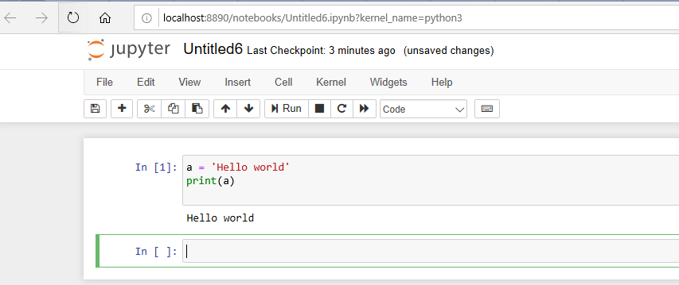

**Answer 2)**

For i in range(2000,3201)

If i % 2 ==0 and i% 5 ==0:

Print(i , end =’ , ‘)

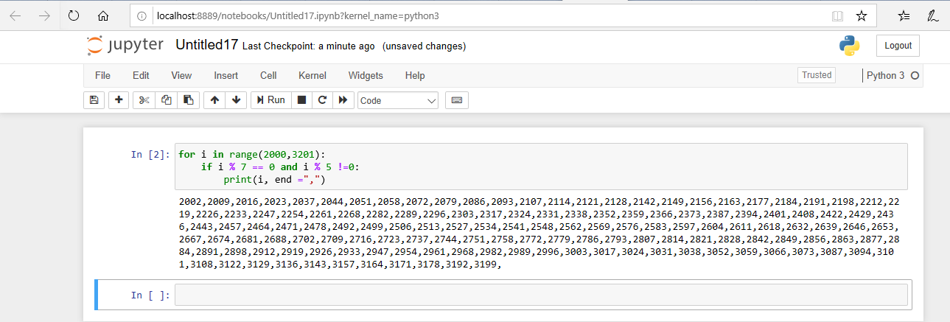

**Answer 3)**

First_name = input ( “please write your first name: “)[::-1]

last_name = input ( “please write your last name: “)[::-1]

print(last_name+ “” +first_name)

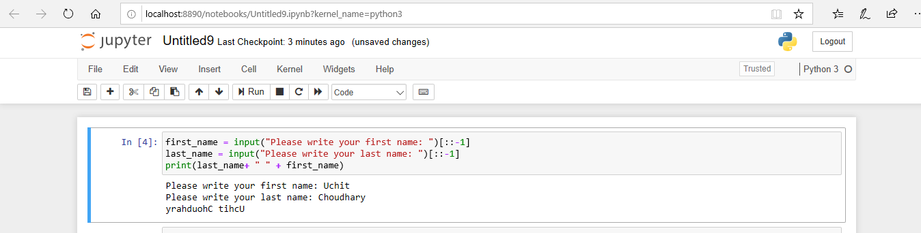

**Answer 4)**

Pi = 22/7

Diameter = int(input(“enter the value of diameter”))

R = diameter/2

Volume = 4/3*pi* r*r*r

Print (“volume of a sphere is “ + str(volume))

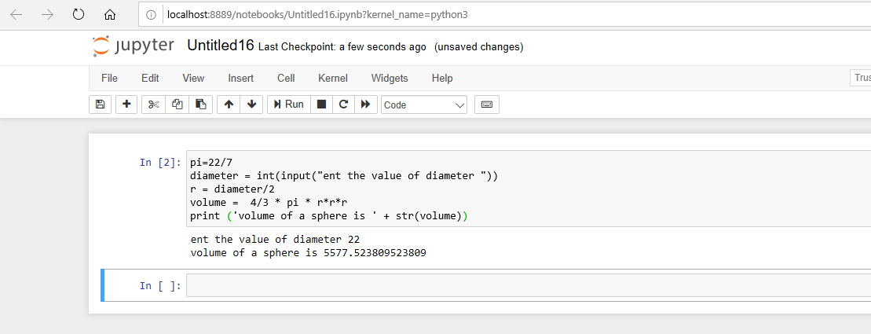

**Task2:**

**Answer** 1) No submission

**Answer 2)**

For I in range(0,5)

For j in range (i+1)

Print (“*”, end = “”)

Print()

For I in range(3,-1,-1)

For j in range (i+1)

Print (“*”, end = “”)

Print()

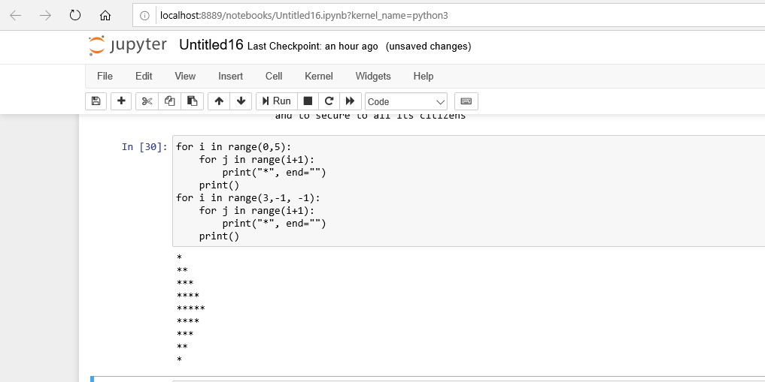

**Answer 3)**

Word = input(“enter a given work”)[::-1]

Print(word)

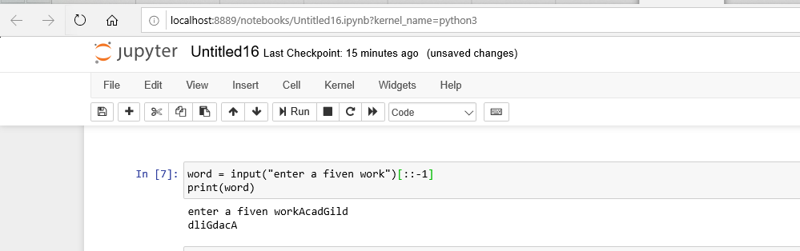

**Answer** 4)

Print(“WE, THE PEOPLE OF INDIA**,\n\t** having solemnly resolved to constitute India into a SOVEREIGN,\**n\t\t** ! SOCIALIST, SECULAR, DEMOCRATIC REPUBLIC \**n\t\t** and to secure to all its citizens”)

